LEBANESE AMERICAN UNIVERSITY

Thesis Full Title All First Letters Capital: Subtitle Same as Title and Both Should be Single Spaced

By

Student Full Name
(The student's name should include her/his First name, and Family name. – Delete this note after applying it)

A thesis
submitted in partial fulfillment of the requirements
for the degree of Master of ….. in …..(Science in Human Resources Management)

Your School Full Name
Month Year of Defense
(This page is not numbered and not counted - Delete this note after applying it)

© 2022

Your Full Name

All Rights Reserved
(This optional page is not numbered and not counted- Delete this note after applying it)

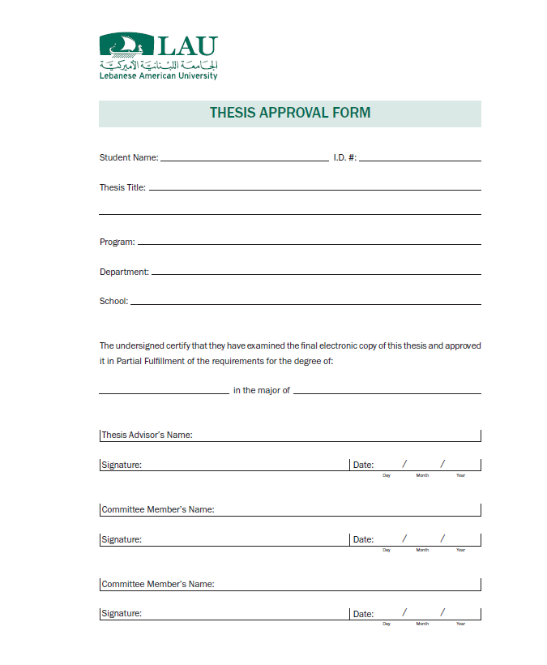(Roman numbering starts here with Thesis Approval Form being number ii, delete this note after applying it)
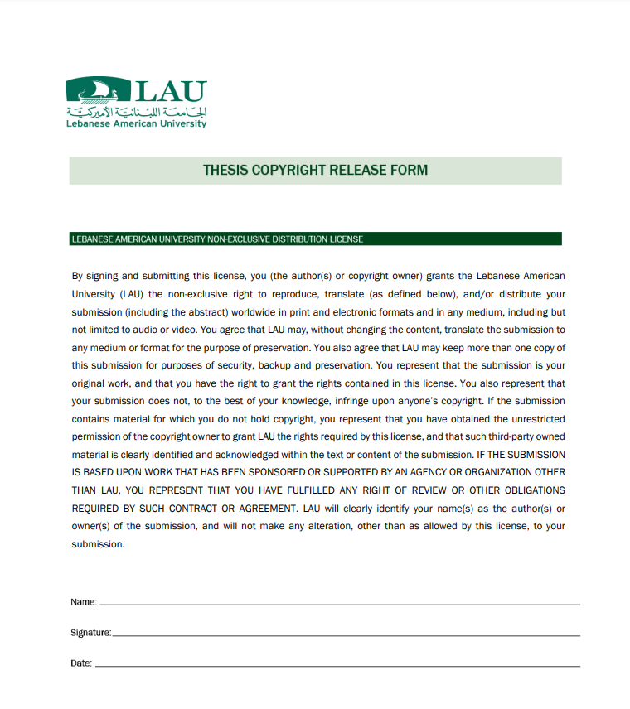

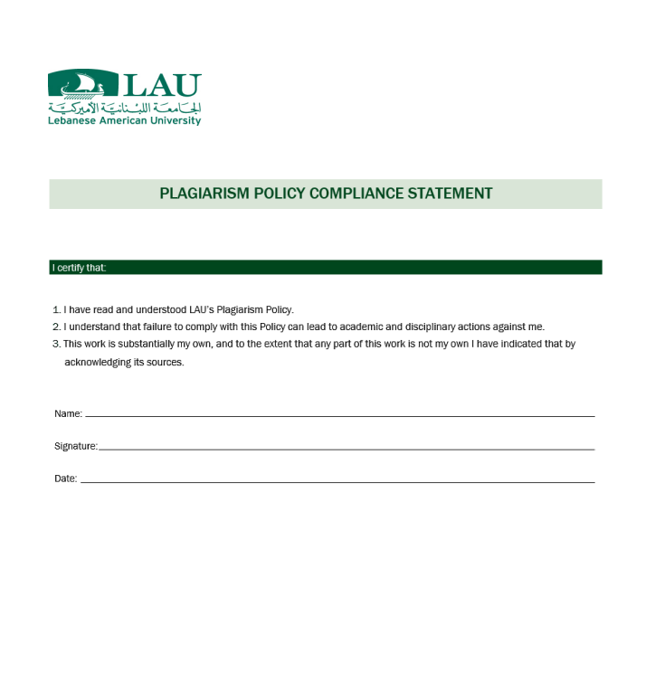

DEDICATION
(Optional: If not available, delete this page, or delete this note after applying it)

A dedication is an honorific statement from the author to a person or group to whom the author commends the effort and product of the thesis. It may or may not bear the title “Dedication” and its text should be brief.

For DEDICATION, ABSTRACT and ACKNOWLEDGMENT pages, the texts are Single spaced. Do not use indentation at the beginning of the paragraphs, and the whole document should be left aligned. While you use single space between paragraphs in Dedication, Acknowledgment and Abstract pages, line spacing in the rest of the document should be one and a half spaced or double spaced provided that you are consistent in your spacing choice.

ACKNOWLEDGMENT
(Optional: If not available, delete this page, or delete this note after applying it)

This optional section is traditionally included in all theses. It is the place for the author to acknowledge professionally the various sources of direction, assistance, etc., that facilitated the work.

Thesis Full Title All First Letters Capital: Subtitle Same as Title and Both Should be Single Spaced

Student Full Name

ABSTRACT
(ABSTRACT text here follows the same guidelines as the ACKNOWLEDGMENT page- delete this note after applying it)

The Abstract summarizes the contents of the document and should include the document full title and the author’s full name. At the end of your “Abstract” you are kindly asked to provide a minimum of 5 “Keywords”, separated with commas, as index terms that clearly identify and reflect the subject of your document. Capitalize the first letter of each keyword. Example below:

Keywords: Keywords are Listed Here, They are Separated with Commas, Each First Letter is Capital, keywords Four, Keywords Five.

TABLE OF CONTENTS

DEDICATION v
ACKNOWLEDGMENT vi

ABSTRACT vii
TABLE OF CONTENTS viii
LIST OF TABLES x
LIST OF FIGURES xi
LIST OF ABBREVIATIONS xii
i - tITLE OF CHAPTER ONE 1
1.1 Main Section Heading 1
1.2 Main Section Heading 1
1.2.1 Second Heading 2
ii - tITLE OF CHAPTER TWO 3
2.1 Main Section Heading 3
2.1.1 Second Heading 3
2.1.2 Second Heading 5
iii - TITLE OF CHAPTER THREE 7
3.1 Lorem Ipsum 7
3.2 Lorem ipsum dolor 8
3.2.1 Convallis tellus 8
REFERENCES / BIBLIOGRAPHY 9
APPENDIX/APPENDICES 11
APPENDIX A: SURVEY 11
APPENDIX B: IRB APPROVAL OF RESEARCH 12

LIST OF TABLES
(If not available, delete this page)

Table 1 - Lebanon's 10 Largest Cities 2
Table 2 - Worst Air Quality in the World 4
Table 3 - Key Informant Interviews 4
Table 4 - Quantitative sample size calculations and achievement 4

LIST OF FIGURES
(If not available, delete this page)

Figure 1 - Population 5
Figure 2 - The Intervention Meets the Expectations of the Recipients 5
Figure 3 - Recipients’ Inclusion and Accountability 6
Figure 4 - Workers’ Inclusion and Accountability 6

LIST OF ABBREVIATIONS
(If not available, delete this page)

FWA……………………………………………………… Flexible Work Arrangements
NNL……………………………………………………… New Normal Leadership

CHAPTER ONE

TITLE OF CHAPTER ONE

The texts should be double spaced and the beginning of each paragraph should be 4 spaces indented.
In order to have your chapter title “This is the First Chapter of Your Thesis” included in the table of contents, kindly select it and go to Home tab in Microsoft word, under styles section choose Heading 1. The Title of the Chapters should be Times New Roman, 18pt. Font Size, Centered, and Bold.

1.1 Main Section Heading
This is the first main section heading under chapter 1. To have it in the table of contents, kindly select the Main Section Heading and go to home tab, under styles section choose Heading 2. The Main Section Heading should be Times New Roman, 14pt. Font Size, and Bold.
The format of the text should be Times New Roman, 12pt. Font Size, and double spaced.

1.2 Main Section Heading
Same guidelines as Main Section Heading 1.1. Ac turpis egestas sed tempus urna et pharetra. Arcu bibendum at varius vel pharetra. Mi quis hendrerit dolor magna eget est. Vitae aliquet nec ullamcorper sit amet risus nullam eget felis.

1.2.1 Second Heading

Same as previous headings, except that this heading is a subheading of Main Section Heading 1.2. And is numbered as (1.2.1). To have it in the table of contents, kindly select the Second Heading and go to home tab, under styles section choose Heading 3. The Second Headings should be Times New Roman, 12pt. Font Size, and Bold. The black Font color is mandatory throughout the thesis except for Tables, Figures and Illustrations’ captions.
Table 1 - Lebanon's 10 Largest Cities
Lebanon - 10 Largest Cities
Name | Population
Beirut, Beyrouth | 1,916,100
Tripoli, Liban-Nord | 229,398
Sidon, South Governorate | 163,554
Tyre, South Governorate | 135,204
Nabatîyé et Tahta, Nabatîyé | 120,000
Habboûch, Nabatîyé | 98,433
Jounieh, Mont-Liban | 96,315
Zahle, Béqaa | 78,145

1.2.1.1 First Subheading

Same as previous headings, except that this heading is a first subheading of the Second Heading 1.2.1 And is numbered as (1.2.1.1). To have it in the table of contents, kindly select the First Subheading and go to home tab, under styles section choose Heading 4. The First Subheading should be Times New Roman, 12pt. Font Size, and regular.
Second Subheading: preferably unnumbered, 12pt. font size, italics.
Nisl rhoncus mattis rhoncus urna neque viverra justo nec. Pretium viverra suspendisse potenti nullam ac tortor.

CHAPTER TWO

TITLE OF CHAPTER TWO

2.1 Main Section Heading
Have you ever read a webpage or document that used this text without paying much attention to it? The lorem ipsum is a placeholder text used in publishing and graphic design. This filler text is a short paragraph that contains all the letters of the alphabet. The characters are spread out evenly so that the reader’s attention is focused on the layout of the text instead of its content. Many software programs and applications have made it their default dummy text. Since the lorem ipsum is always used as a placeholder text, its use indicates that this is not a final version of a document, thus helping to avoid unnecessary printing.

2.1.1 Second Heading

Figures and tables must follow a sequential numbering throughout the document. Table 1 in Chapter 1, and if another table is added in Chapter 1, it could be numbered as 2 or 1.2 to reflect the first chapter.
All tables must have a caption in order to be reflected in the LIST OF TABLES. A caption could be added by selecting the table, clicking right click, selecting “insert caption”, putting the details of the table as needed such as “Table 1-Lebanon’s 10 Largest Cities” in Times New Roman, 12pt. Font Size. Once all the tables are done throughout the document, go to references and press Insert Table of Figures.
Lorem ipsum dolor sit amet, consectetur adipiscing elit, sed do eiusmod tempor incididunt ut labore et dolore magna aliqua. Tellus at urna condimentum mattis pellentesque. Faucibus scelerisque eleifend donec pretium vulputate sapien nec. Mauris cursus mattis molestie a iaculis at erat pellentesque adipiscing. Egestas egestas fringilla phasellus faucibus scelerisque eleifend. Integer quis auctor elit sed vulputate mi. Accumsan lacus vel facilisis volutpat est velit egestas.

Table 2 - Worst Air Quality in the World
World– Most Polluted Countries
Name | AVG. US
Bangladesh | 161
Chad | 161
Pakistan | 156
Tajikistan | 152
India | 151
Oman | 146
Kyrgyzstan | 138
Bahrain | 136

Blandit libero volutpat sed cras. Scelerisque eleifend donec pretium vulputate sapien nec sagittis aliquam malesuada. Vulputate odio ut enim blandit volutpat maecenas volutpat blandit aliquam. Nulla aliquet enim tortor at auctor urna nunc id cursus. Malesuada fames ac turpis egestas maecenas pharetra convallis posuere morbi.
Table 3 - Key Informant Interviews
Stakeholder | Number of KIIs
Mayors | 1
Governors | 4
Police Officers | 1
Member of Parliament | 1
Total | 7

Table 4 - Quantitative sample size calculations and achievement
Project Pillar | Total sampling frame | Sampling fraction | Sample size parameters | Sample size | Achieved
Pillar 1: Renovation | 153 Lebanese and Syrian households | 47 Lebanese households (0.31) | 95% confidence interval, 3% margin of error | 42 | 42
Pillar 2: Cash-for-work |  | 95 Syrian refugees (0.62) |  | 83 | 87
 |  | 11 Lebanese households (0.07) |  | 9 | 9
 |  | Total |  | 134 | 141

2.1.2 Second Heading

All Figures must have a caption in order to be reflected in the LIST OF FIGURES. A caption could be added by selecting the figure, clicking right click, selecting “insert caption”, putting the details of the figure as needed such as “Figure 1: Population” in Times New Roman, 12pt. Font Size. Once all the Figures are done throughout the document, go to references and press Insert Table of Figures.
Figure 1- Population

Lorem ipsum dolor sit amet, consectetur adipiscing elit, sed do eiusmod tempor incididunt ut labore et dolore magna aliqua. Bibendum est ultricies integer quis auctor. Vitae et leo duis ut diam quam. Lacinia quis vel eros donec ac odio tempor.
Figure 2 - The Intervention Meets the Expectations of the Recipients

2.4. Insert a Horizontal Page
To insert a horizontal page in the middle of your document, click on this link and follow the instructions.

CHAPTER THREE

TITLE OF CHAPTER THREE

Lorem ipsum dolor sit amet, consectetur adipiscing elit, sed do eiusmod tempor incididunt ut labore et dolore magna aliqua. Tellus at urna condimentum mattis pellentesque. Faucibus scelerisque eleifend donec pretium vulputate sapien nec. Mauris cursus mattis molestie a iaculis at erat pellentesque adipiscing. Egestas egestas fringilla phasellus faucibus scelerisque eleifend. Integer quis auctor elit sed vulputate mi.

3.1 Lorem Ipsum
Ac turpis egestas sed tempus urna et pharetra. Arcu bibendum at varius vel pharetra. Mi quis hendrerit dolor magna eget est. Lorem ipsum dolor sit amet, consectetur adipiscing elit, sed do eiusmod tempor incididunt ut labore et dolore magna aliqua.

Figure 3 - Recipients’ Inclusion and Accountability

3.2 Lorem ipsum dolor
A lacus vestibulum sed arcu non odio euismod lacinia at. Laoreet sit amet cursus sit amet dictum sit amet justo. Hac habitasse platea dictumst quisque sagittis purus. Tempus iaculis urna id volutpat lacus laoreet non curabitur gravida.
Figure 4 - Workers’ Inclusion and Accountability

3.2.1 Convallis tellus

Convallis tellus id interdum velit. Leo duis ut diam quam nulla porttitor massa id. Aliquet bibendum enim facilisis gravida neque convallis.

3.2.1.1 First Subheading

Malesuada fames ac turpis egestas maecenas pharetra convallis posuere morbi. Nisl suscipit adipiscing bibendum est ultricies integer. Nisl rhoncus mattis rhoncus urna neque viverra justo nec.
If you have a Second Subheading i.e., 3.2.1.1.1it is preferable to keep it unnumbered, font Times New Roman, font size 12pt., italics.

REFERENCES / BIBLIOGRAPHY

(Name this section either References or Bibliography and list your citations as per the writing style recommended by your advisor throughout the thesis)

APPENDIX/APPENDICES

(If more than one Appendix, use the plural Appendices and the Alphabetical numbering, if none, please delete this section)

APPENDIX A: SURVEY

APPENDIX B: IRB APPROVAL OF RESEARCH
(If you have an IRB form, please insert the original colored signed copy here)

Glossary of Terms

(It is an alphabetical list of terms in a particular domain of knowledge with the definitions for those terms. Optional: If not available, delete this page, or delete this note after applying it)

